

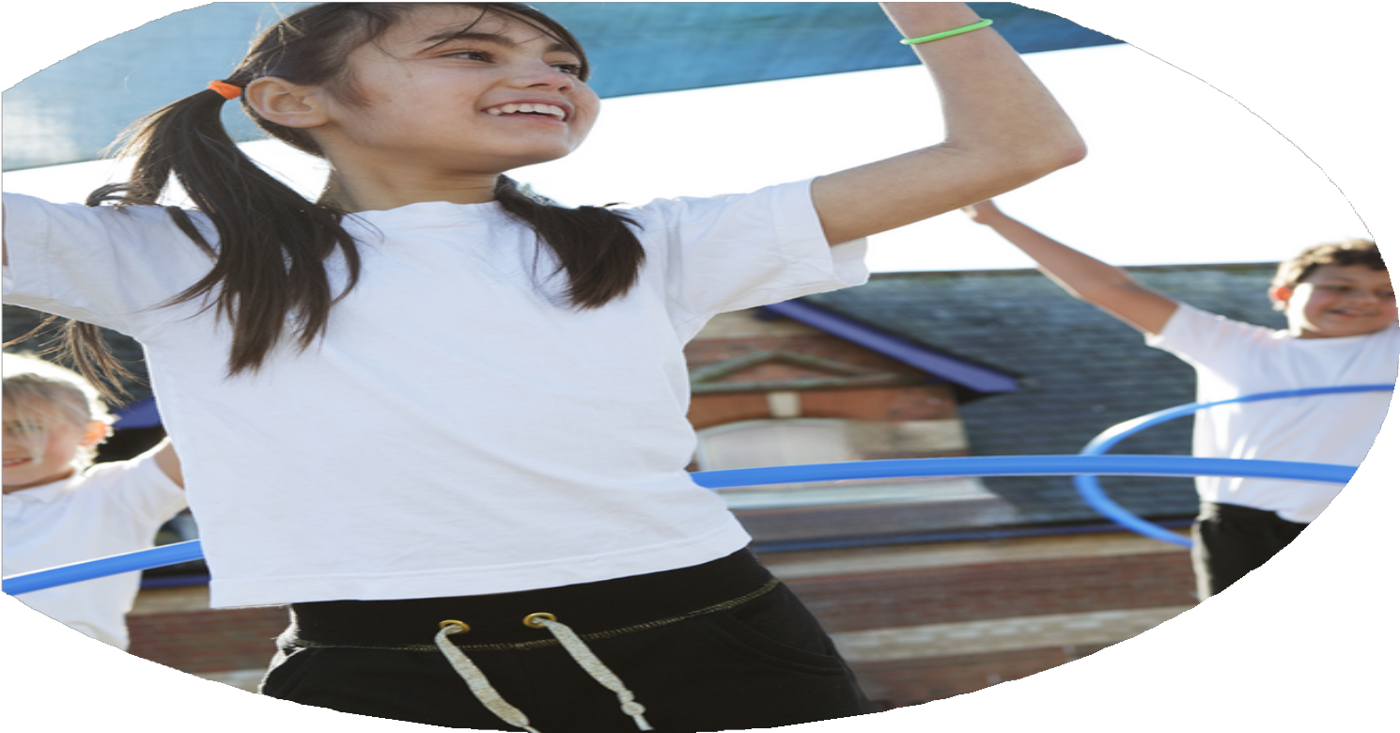
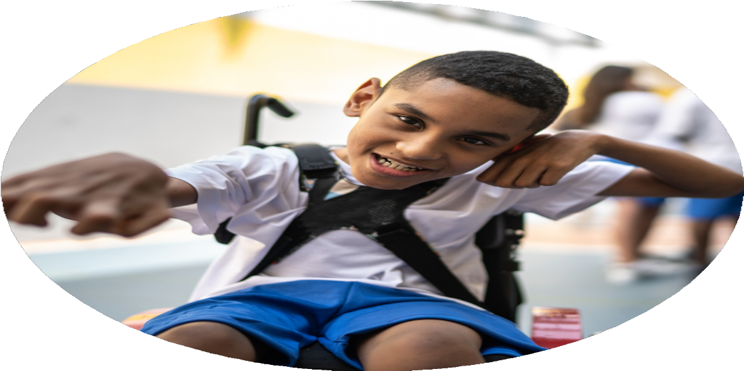
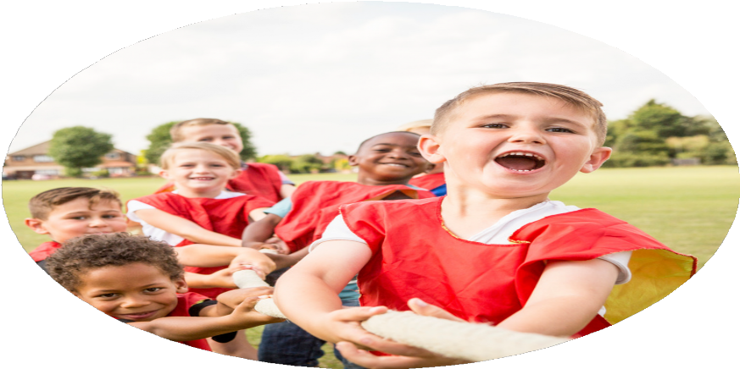



The Primary PE

and Sport Premium
Planning, reporting and evaluating website tool.

Created by Claire Greenwood
Commissioned by

Images courtesy of Youth Sport Trust

PE Funding Evaluation Form

It is intended that this template should be used as preparation for the completion of the statutory digital reporting tool being introduced this academic year. You can upload data (including swimming) from this template onto this platform once it becomes accessible.
- Before you decide how you are going to use the funding for this academic year you should reflect and evaluate the impact of your use of the funding in 2024/25.
All spending of the funding must conform with the terms outlined in the Conditions of Grant document. The template is a working document that you can amend/update during the year.
Based on your evaluation of last year’s funding you should decide what you intend to do this academic year, how you will do it, and what impact you expect it to have.

It is important that the funding is used effectively and based on your school’s needs.
You must use the funding to make additional and sustainable improvements to the PE and sport in your school. You must develop and add to the PESSPA activities that your school already offers.

Summative digital reporting from June 2025 will continue to include swimming and water safety information therefore funding can be used to provide top-up lessons where necessary to ensure pupils meet national curriculum swimming requirements.

Review of last year 2024/25
We recommend that you start by reflecting on the impact of current provision and reviewing your previous spend.

What went Well | How do you know | What did not go well | How do you know
Swimming competency among KS2 students | Students who needed extra support were identified early and additional sessions built in.  Targeted support | A small number of year 6 students did not meet the national curriculum standard. | Data analysis/feedback from swimming teachers.
Bikability training to all year 6 pupils. | High success rate of pupils with Bikability level 2.  92% of year completed the course successfully | A small number of children did not reach the expected level | Feedback and outcomes from training
Additional staff members qualified Forest School teachers with comprehensive first-aid training. | Training complete for additional forest school teacher and forest school first aid covered. | N/A | Certified course
Coaching for teachers, supported by external experts | Staff confidence and quality of provision |  | Lesson observations/feedback from staff/pupil voice
Mitigating rural barriers by providing transportation for sporting events and competitions. | Pupils have been part of cluster sports events in rugby, cricket, athletics, football and cross country. | KS1 children need to be the next focus. | Event registers and participation records.
Young leaders' programs and enhance break-time activities with new equipment to target inactive pupils/Pupil premium pupils and pupils with SEND | All schools have sports leaders who are leading active play.  Equipment in all schools to support active play.  Training and monitoring of playleaders from PE leader | Ongoing training needed to ensure legacy | Training records/playtime observations
Improved PE delivery through use of secondary school facilities. | All KS2 PE using secondary school grounds and resources.  Increased range of activities in PE curriculum as a result. | NA | Observations/planning/resourcing

Intended actions for 2025/26

What are your plans for 2025/26 | How are you going to action and achieve these plans? | How is money spent?
Intent | Implementations
Objective: To continue to build on swimming competency among KS2 students by delivering year-round top-up sessions | All year-round swimming offered to KS2 groups.  Children at risk of not meeting the National curriculum standard identified and top up sessions delivered.  Expected Impact: Higher percentages of Year 6 students meeting National Curriculum standards. | Staff costs  Transport
Objective: To deliver Bikability training to all year 6 pupils. | All year 6 children receiving fully funded bikability training.  All year 6 receiving training on Highway code and staying safe on the roads.  Expected impact: Increased awareness of road safety and improved competency. | Trainer and delivery
Objective: To further enhance PE training and coaching for teachers, supported by external experts (KANGA and Federation staff). | All staff receive PE CPD sessions.  Teachers delivering PE have access to regular training/coaching and feedback.  Expected Impact: Increased teacher confidence and improved quality of PE instruction. | PE CPD courses and trainers
Objective: To continue to mitigate rural barriers by providing transportation for sporting events and competitions. | Children can access PE with their peer groups.  High quality and developmentally appropriate challenge in PE due to year group provision in KS2  Swimming top ups delivered.  Expected Impact: Increased participation in intra- and inter-school sports, fostering inclusion and team spirit. | Federation PE buses  Minibus- competitions/Federation PE  Drivers/fuel/maintenance
Objective: To further strengthen young leaders' programs and enhance break-time activities with new equipment to target inactive pupils/Pupil premium pupils and pupils with SEND.  To build on leaders training leaders for legacy. | Further investment in playtime equipment  Build a young leaders programme in each school.  Expected Impact: Greater student involvement in active lifestyles and leadership roles. | PE lead time (Termly day)  Equipment
Objective: To increase access to after school sports clubs | Work with external companies to launch football club at Federation working and building on this to increase other activities.  Running club numbers to be extended and opened to include year 3. | Staff time
Objective: To increase access to competitive sports both intra and inter school | Increase numbers of pupils accessing the cross-country league.  Cluster rugby event, cross country, football, cricket.  Inter federation sports opportunities planned across the year  Attend Brownlee Triathlon | Staff time  Minibus- competitions/Federation PE  Drivers/fuel/maintenance
Objective: Increased focus on Forest school education to build outdoor active learning opportunities. | KS2 timetabled across the year to complete Forest school  Clear and progressive curriculum  Active learning as focus | Federation buses  Minibus  Drivers/fuel/maintenance
Objective: Build OAA into core PE provision offer | Links with outdoor adventure centres  Kettlewell site to be mapped for orienteering  OAA built into KS2 curriculum and through use of secondary school grounds | Site mapping  OAA resources  Expert training  Training

Expected impact and sustainability will be achieved.

What impact/intended impact/sustainability are you expecting? | How will you know? What evidence do you have or expect to have?
Increased percentage at National curriculum standard for swimming. | Outcomes increase for year 6 swimming data.  Progress seen for identified children
Increased confidence, knowledge and understanding of PE delivery from staff | Staff voice  Lesson observations/learning walks  Staff coaching with DHT, and feedback being used effectively
Increased participation in sport both competitive and non-competitive | Club registers showed increased participation.  Club lists show increased opportunities and variety.  Competitions show increased participation.  Sports days and intra school events well attended.  Pupil voice shows positive impact
Increased health and nutrition understanding in KS1 pupils | Qualified teacher specialist delivers food technology to KS1.  Pupil voice shows pupils have developing understanding on how food impacts health
Stronger partnerships | Training cascaded by our expert teachers building.  Links developed with locality sports providers and children across the federation are involved in opportunities through these links
Increased opportunities for young leadership | Each school will have established young leaders.  Equipment being used effectively in each school.  Pupil voice shows engagement.  Increased participation  Variety in playtime offers
Increased forest school provision and delivery opportunities with secure skills progression. | Increased participation  Skills and progression assessments

What impact/sustainability have you seen?
What evidence do you have?

